# Midterm 1 – Workflow Example with Three Developers Implementing in Parallel Three Maintenance Tasks on Different Task-Branches

# GIT_VISUALIZATION_ALL_BRANCHES after completing Step 0*:*

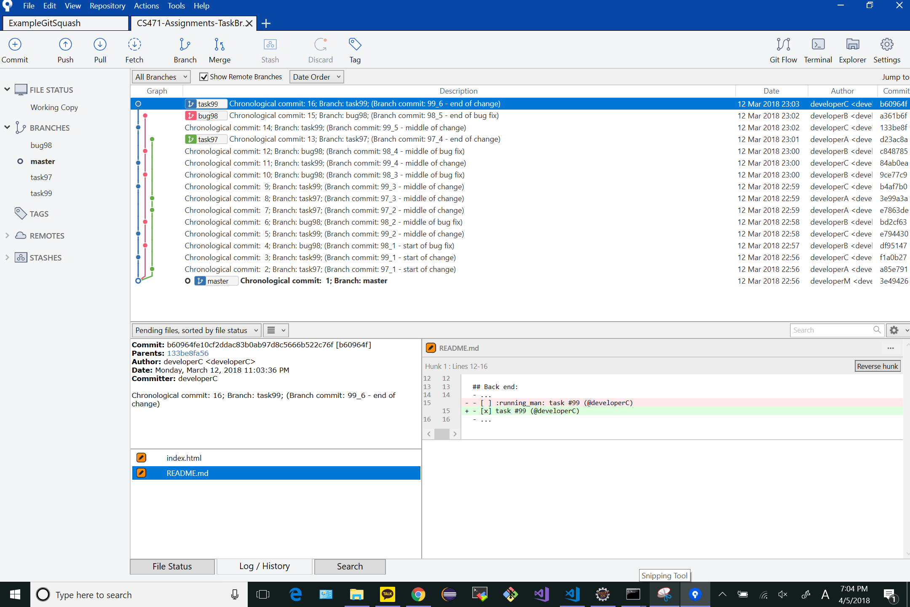

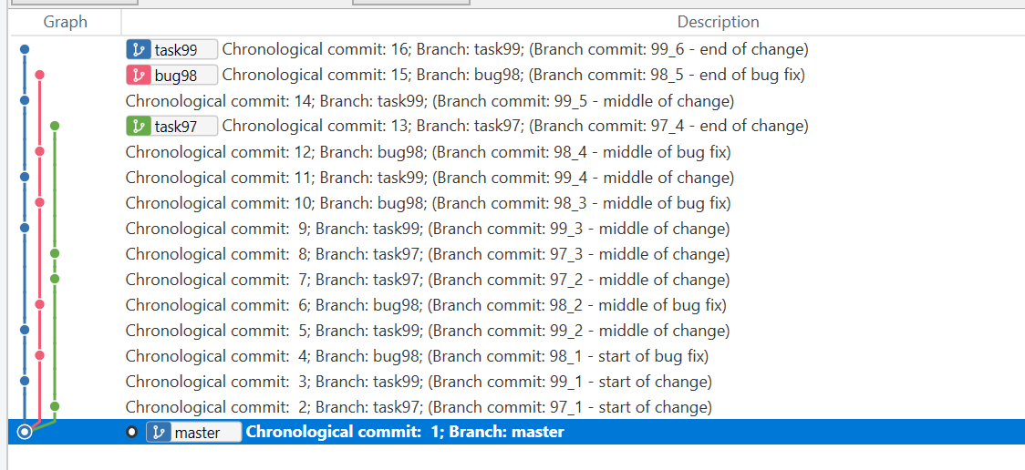

# GIT_VISUALIZATION_ALL_BRANCHES after completing Step 1*:*

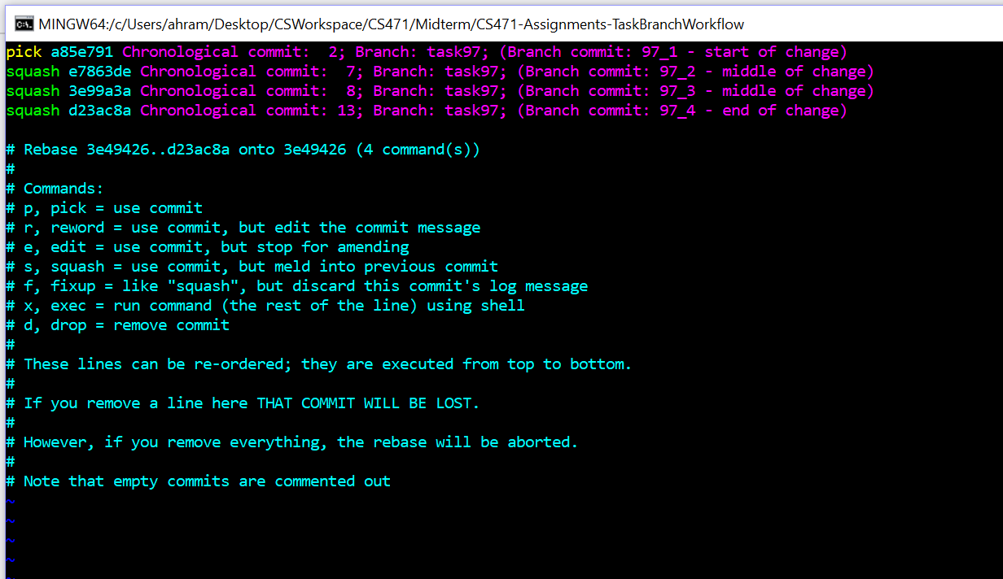

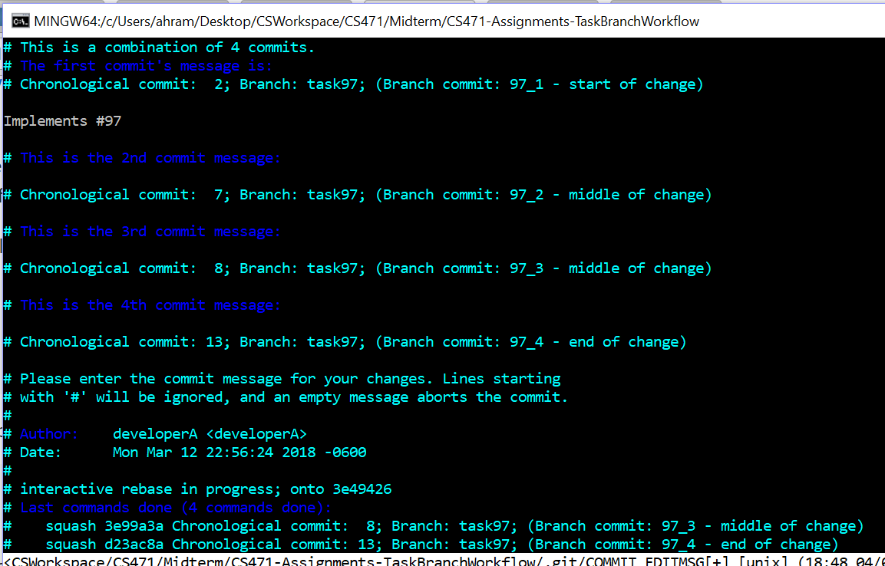

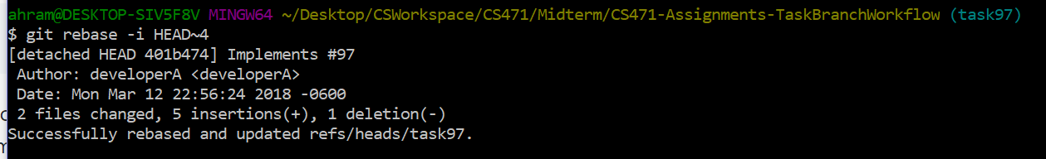

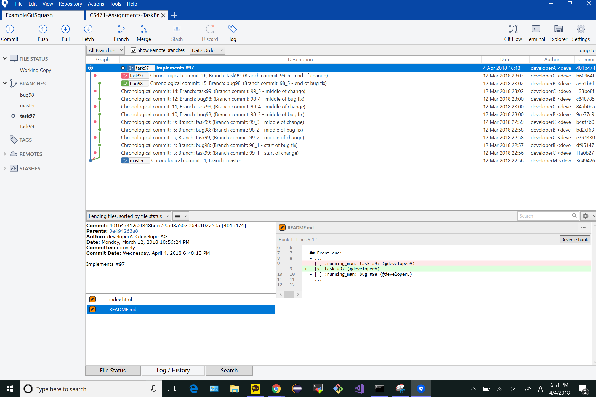

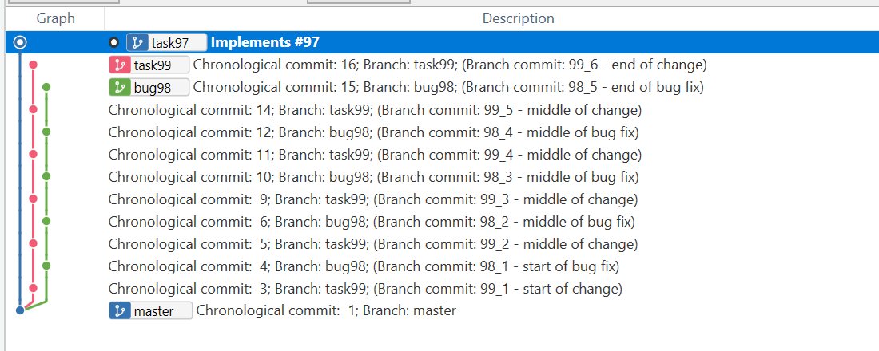

# GIT_VISUALIZATION_ALL_BRANCHES after completing Step 2:

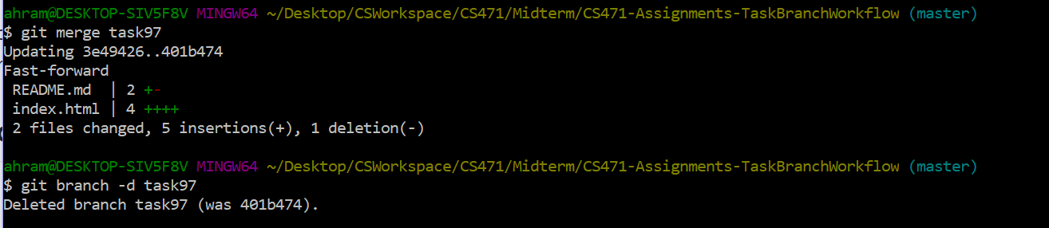

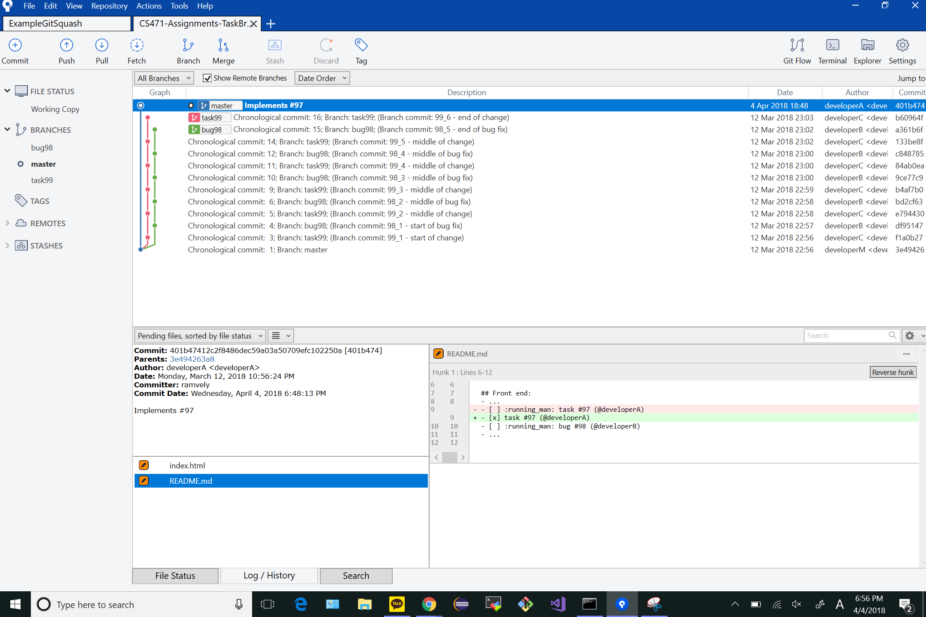

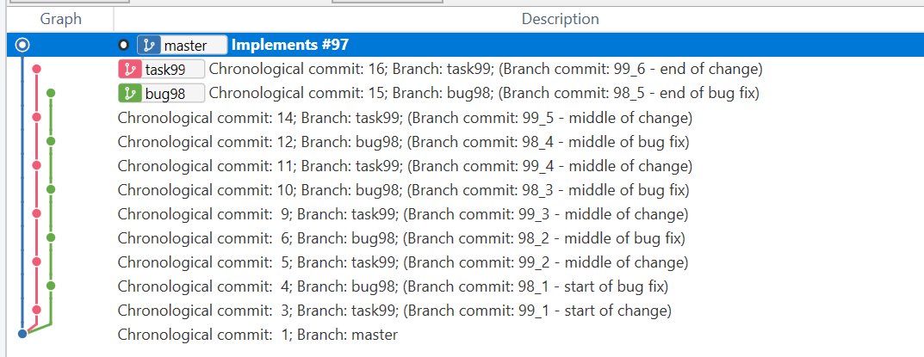

# GIT_VISUALIZATION_ALL_BRANCHES after completing Step 3:

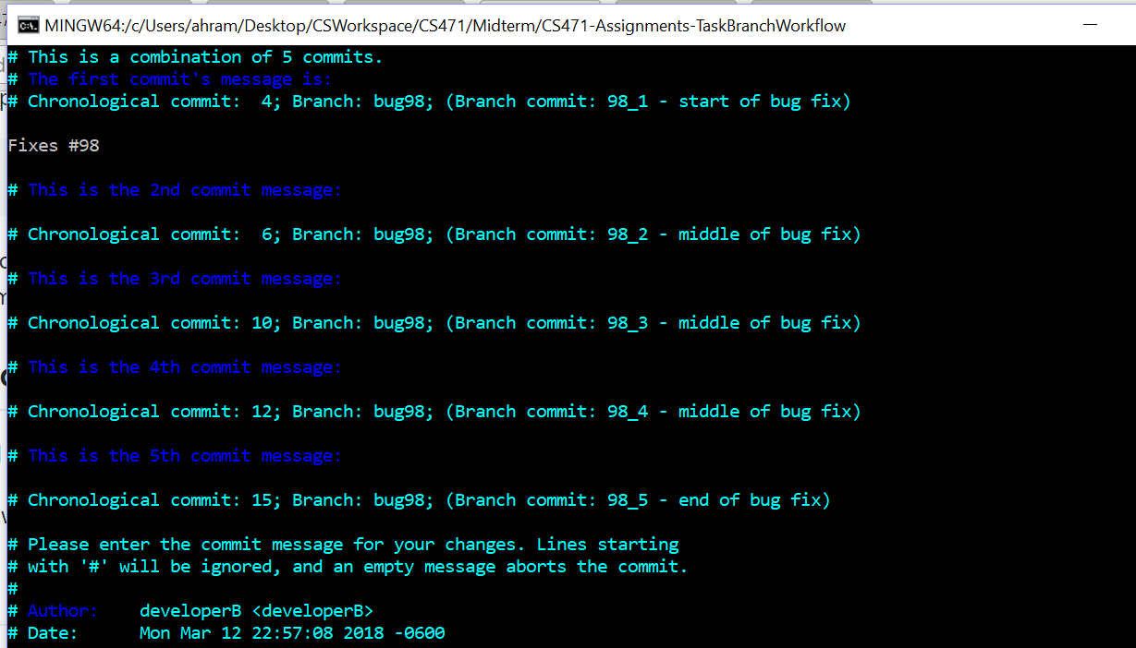

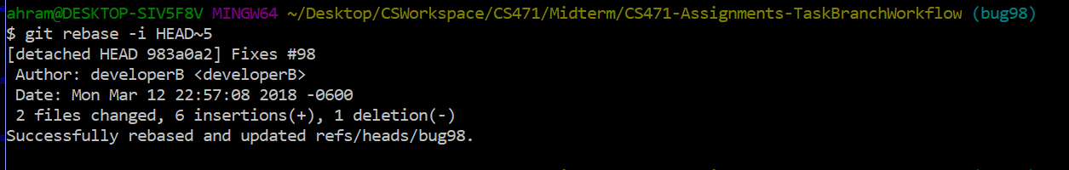

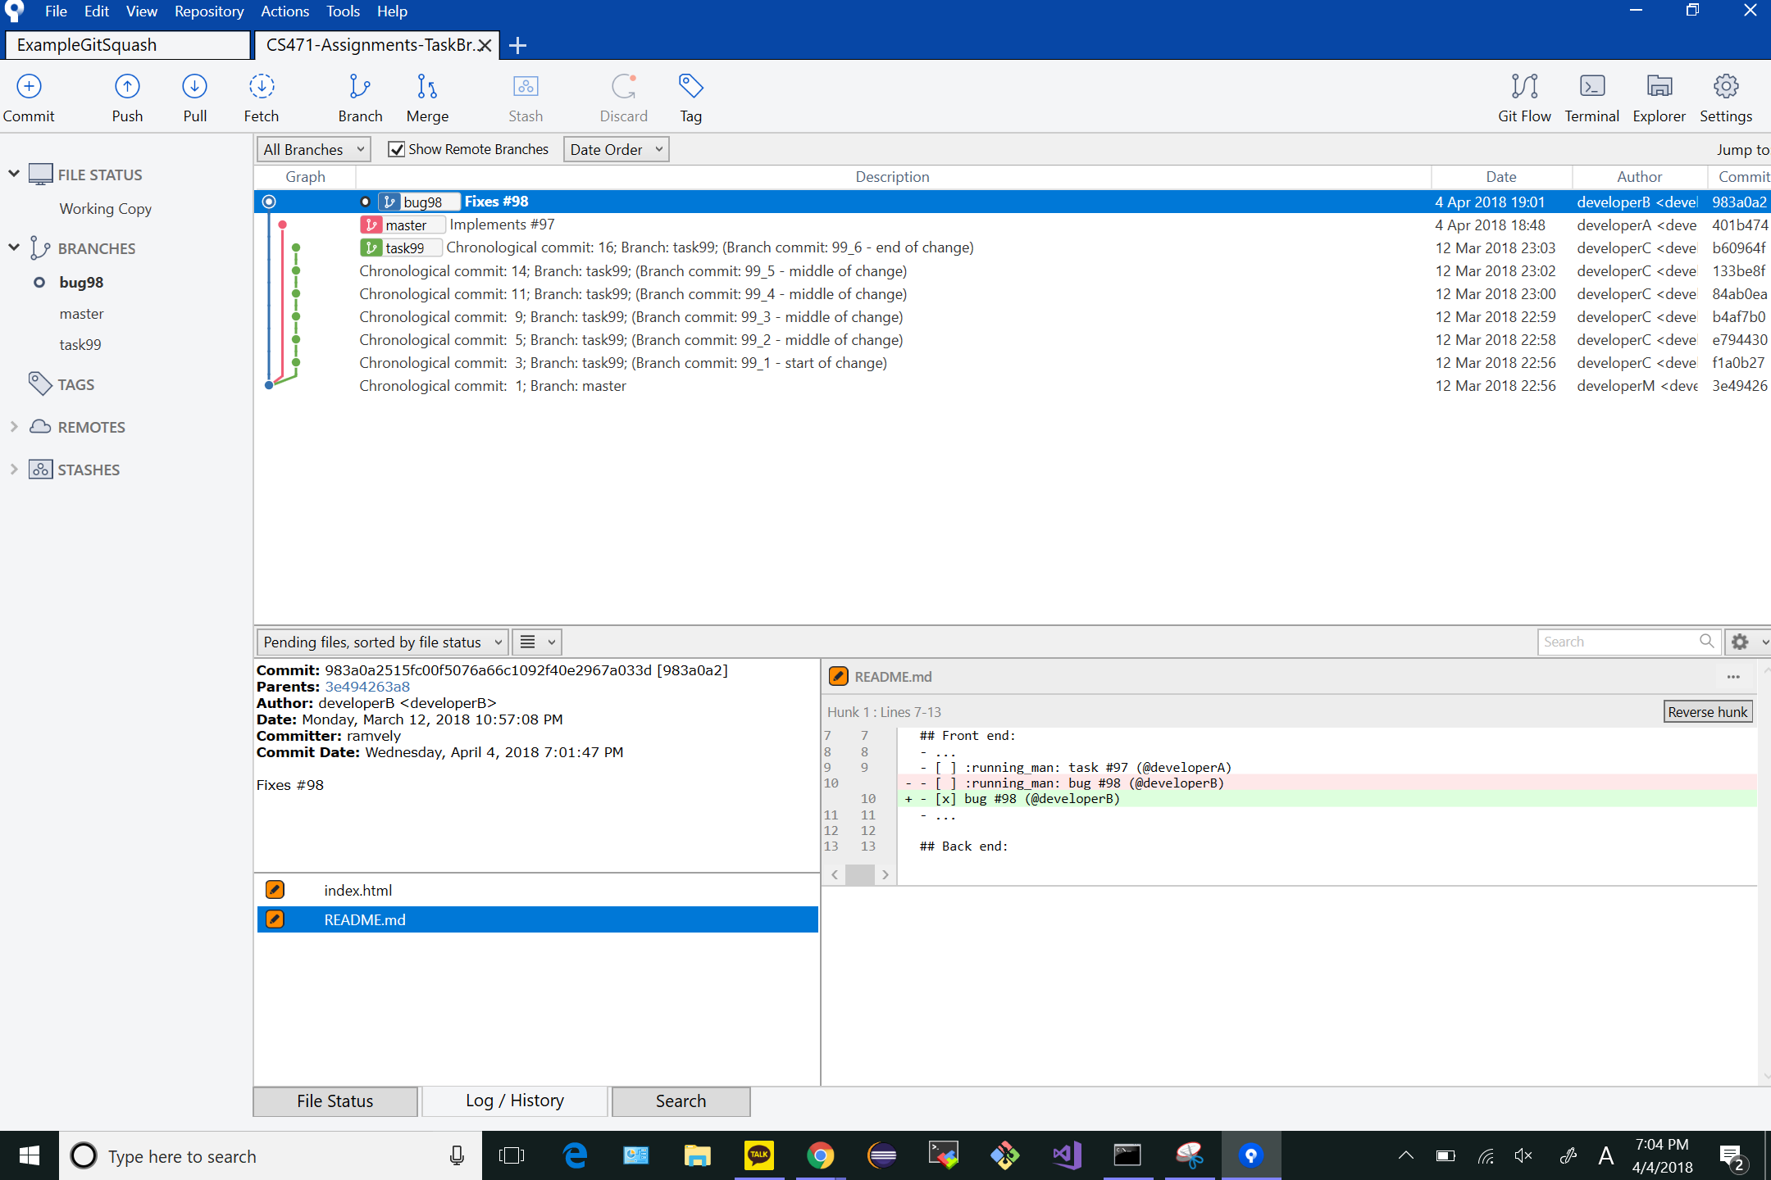

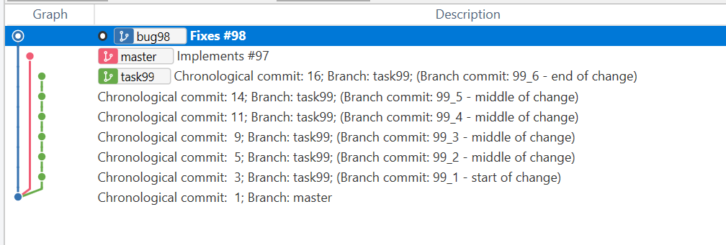

# GIT_VISUALIZATION_ALL_BRANCHES after completing Step 4:

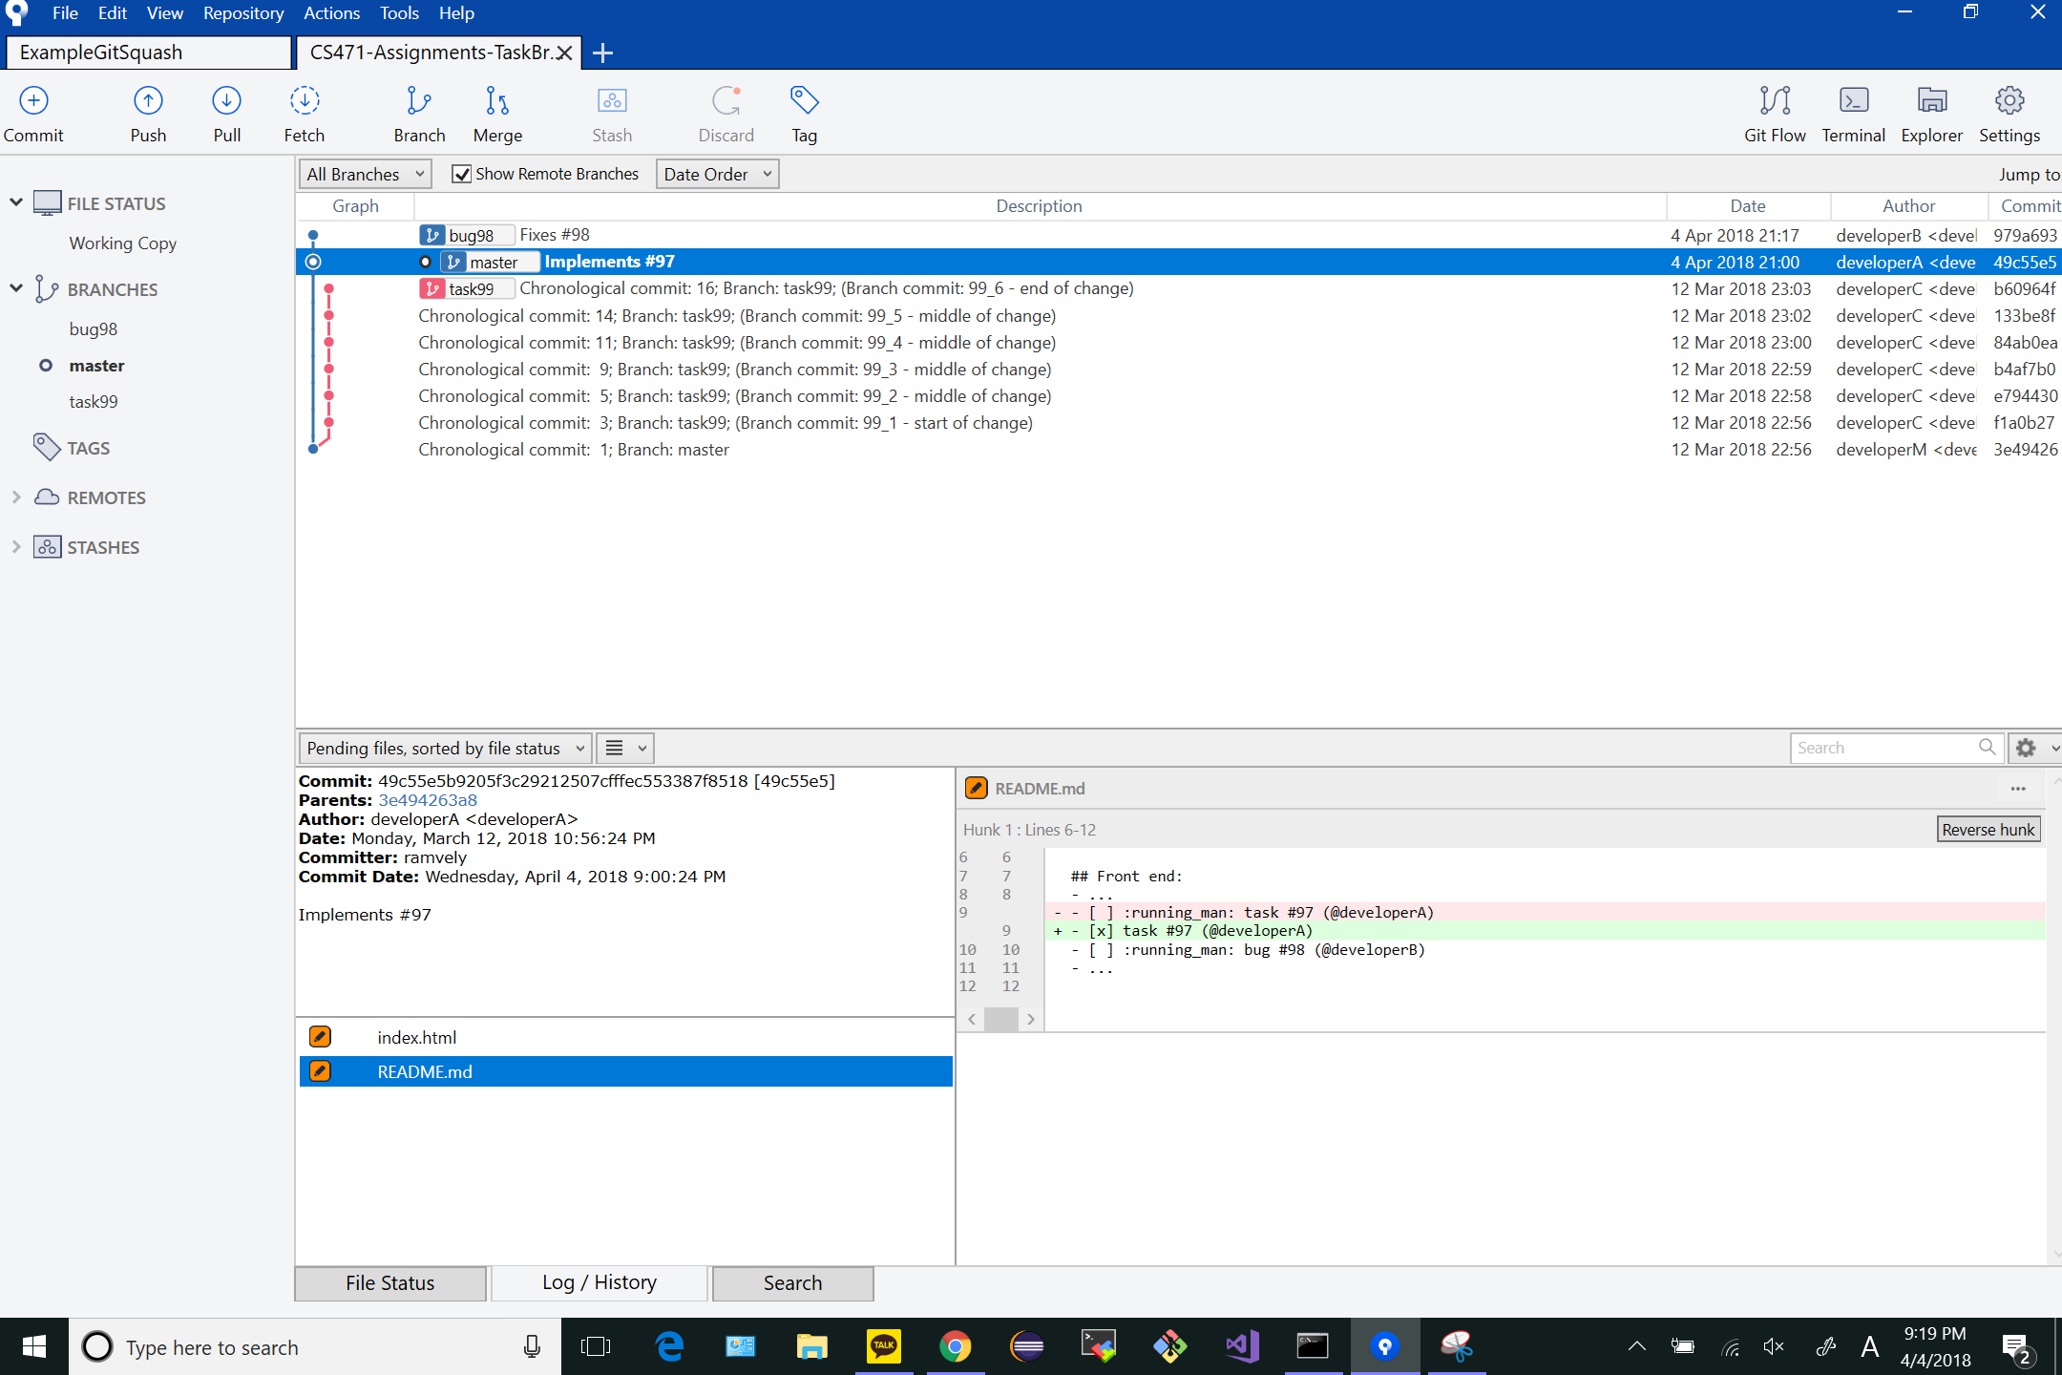

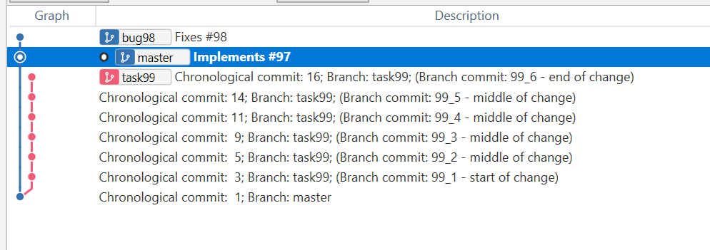

# GIT_VISUALIZATION_ALL_BRANCHES after completing Step 5:

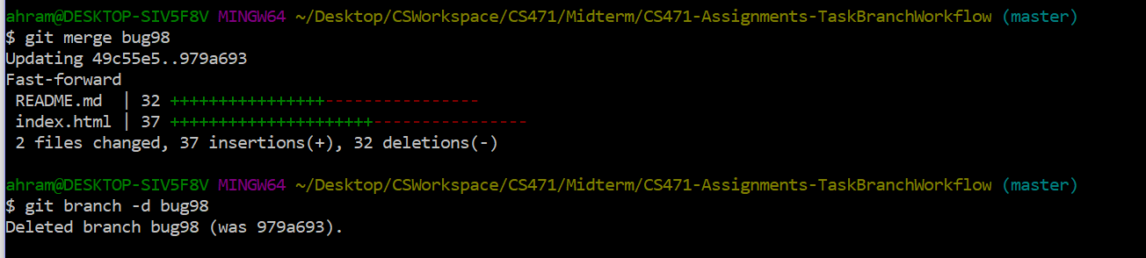

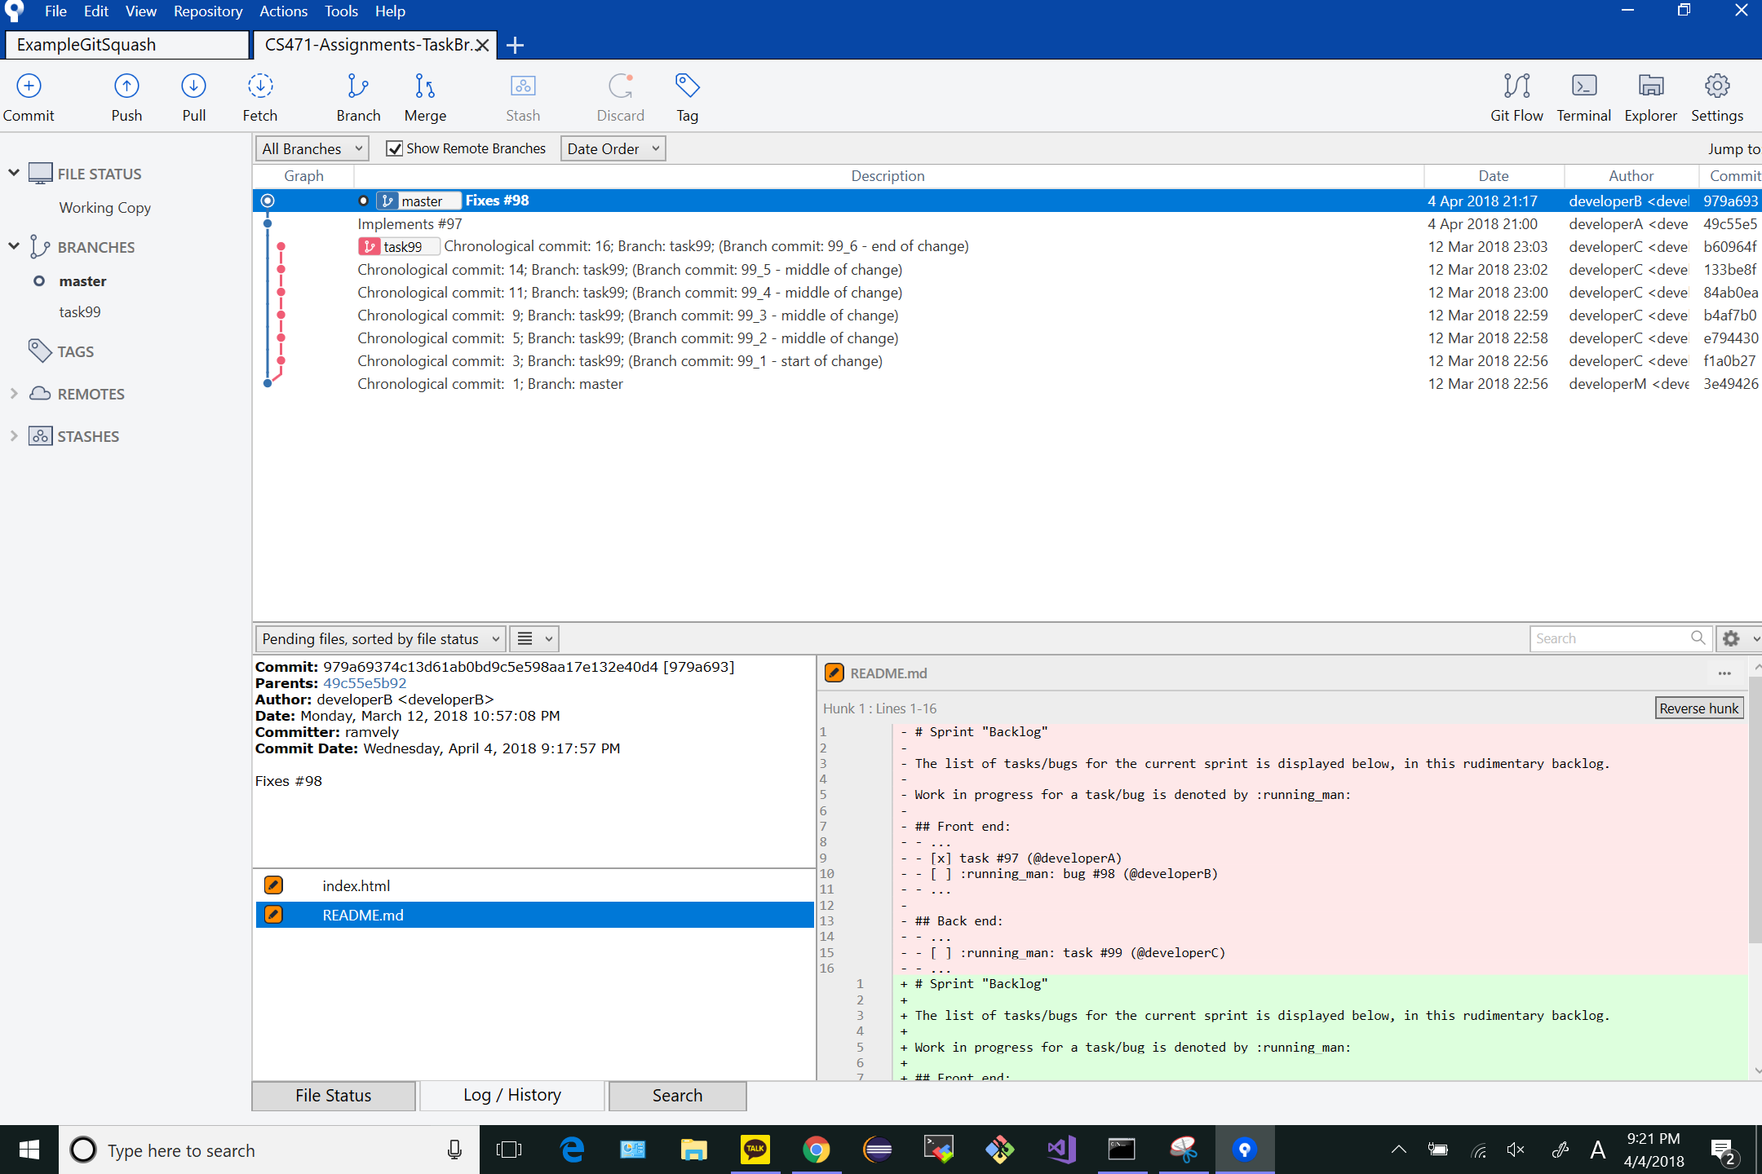

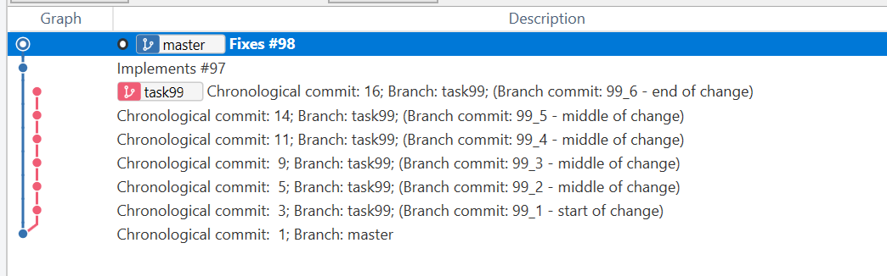

# GIT_VISUALIZATION_ALL_BRANCHES after completing Step 6:

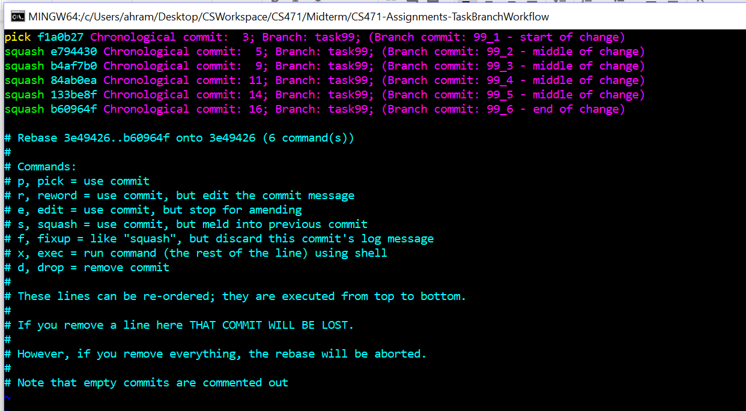

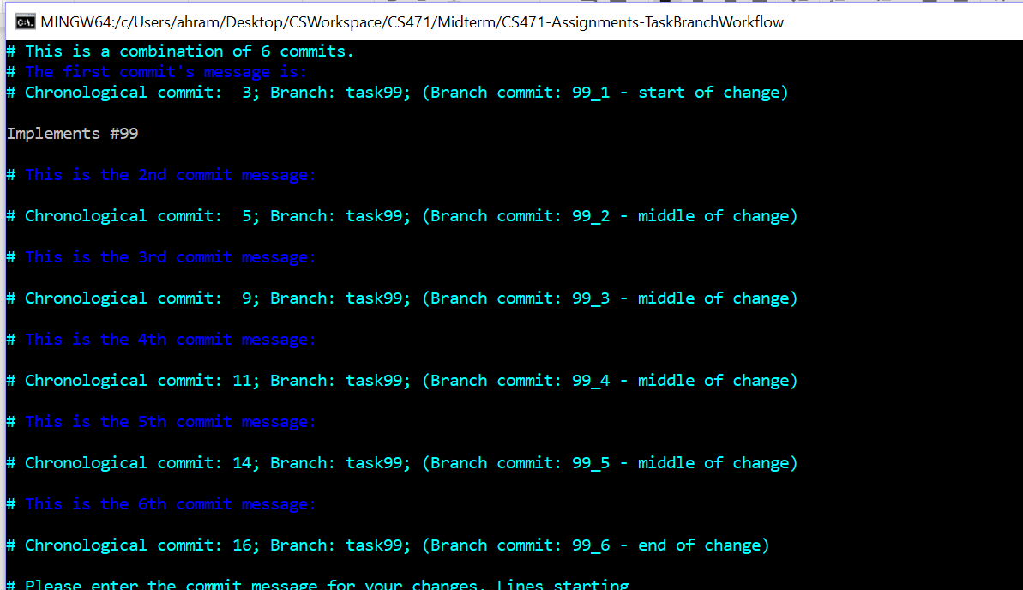

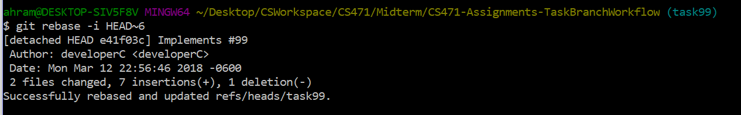

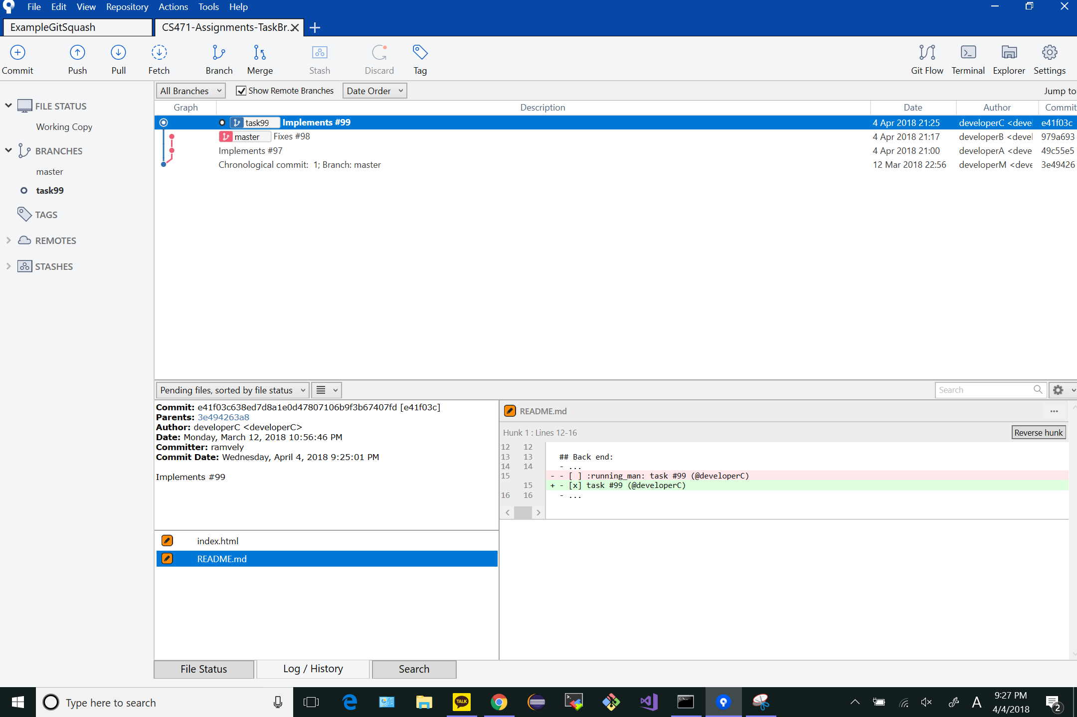

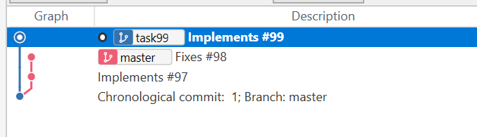

# GIT_MERGE_CONFLICT_VISUALIZATION after completing Step 7:

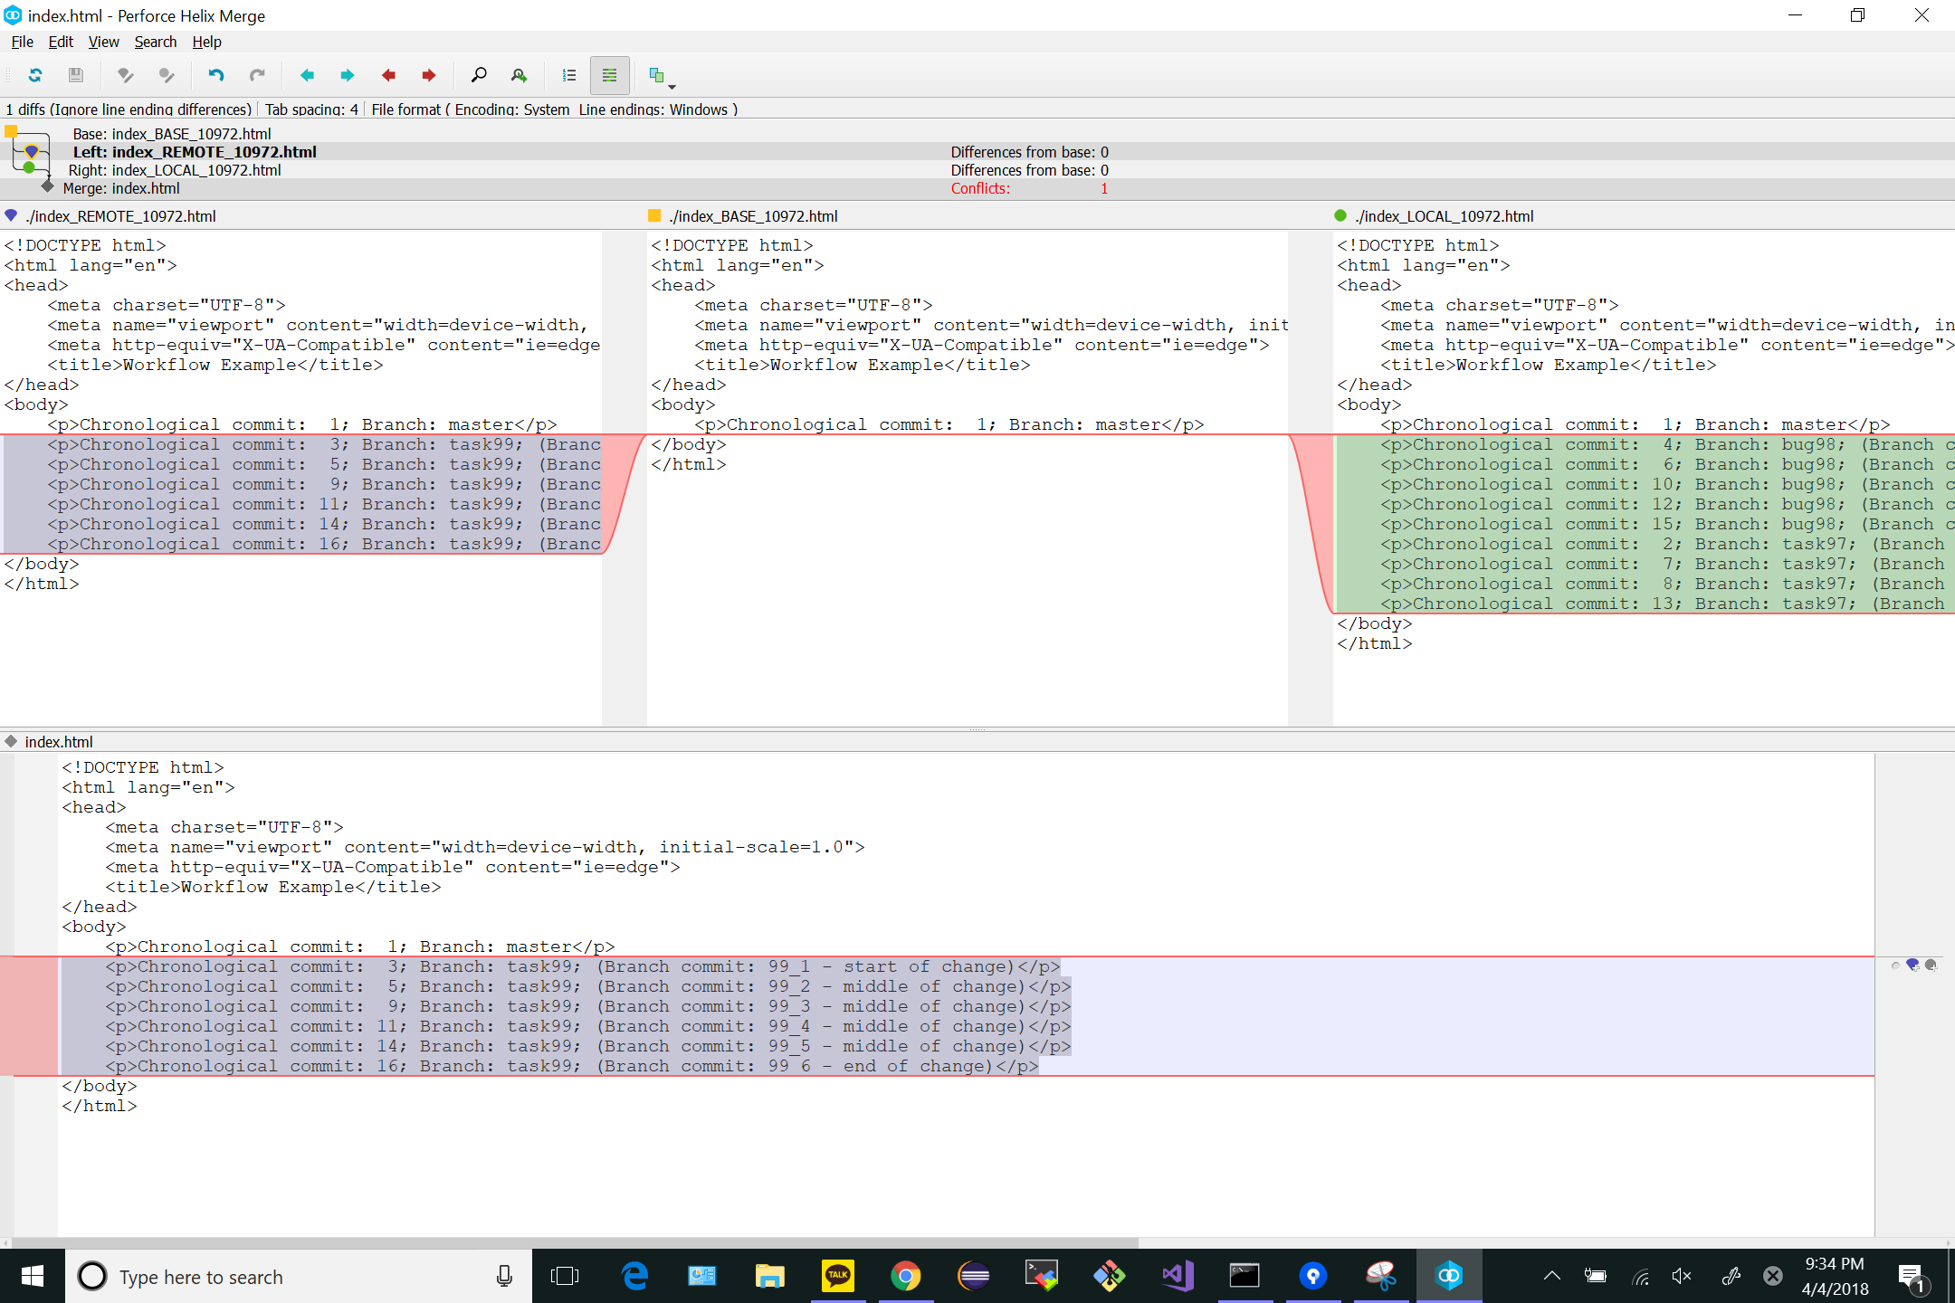

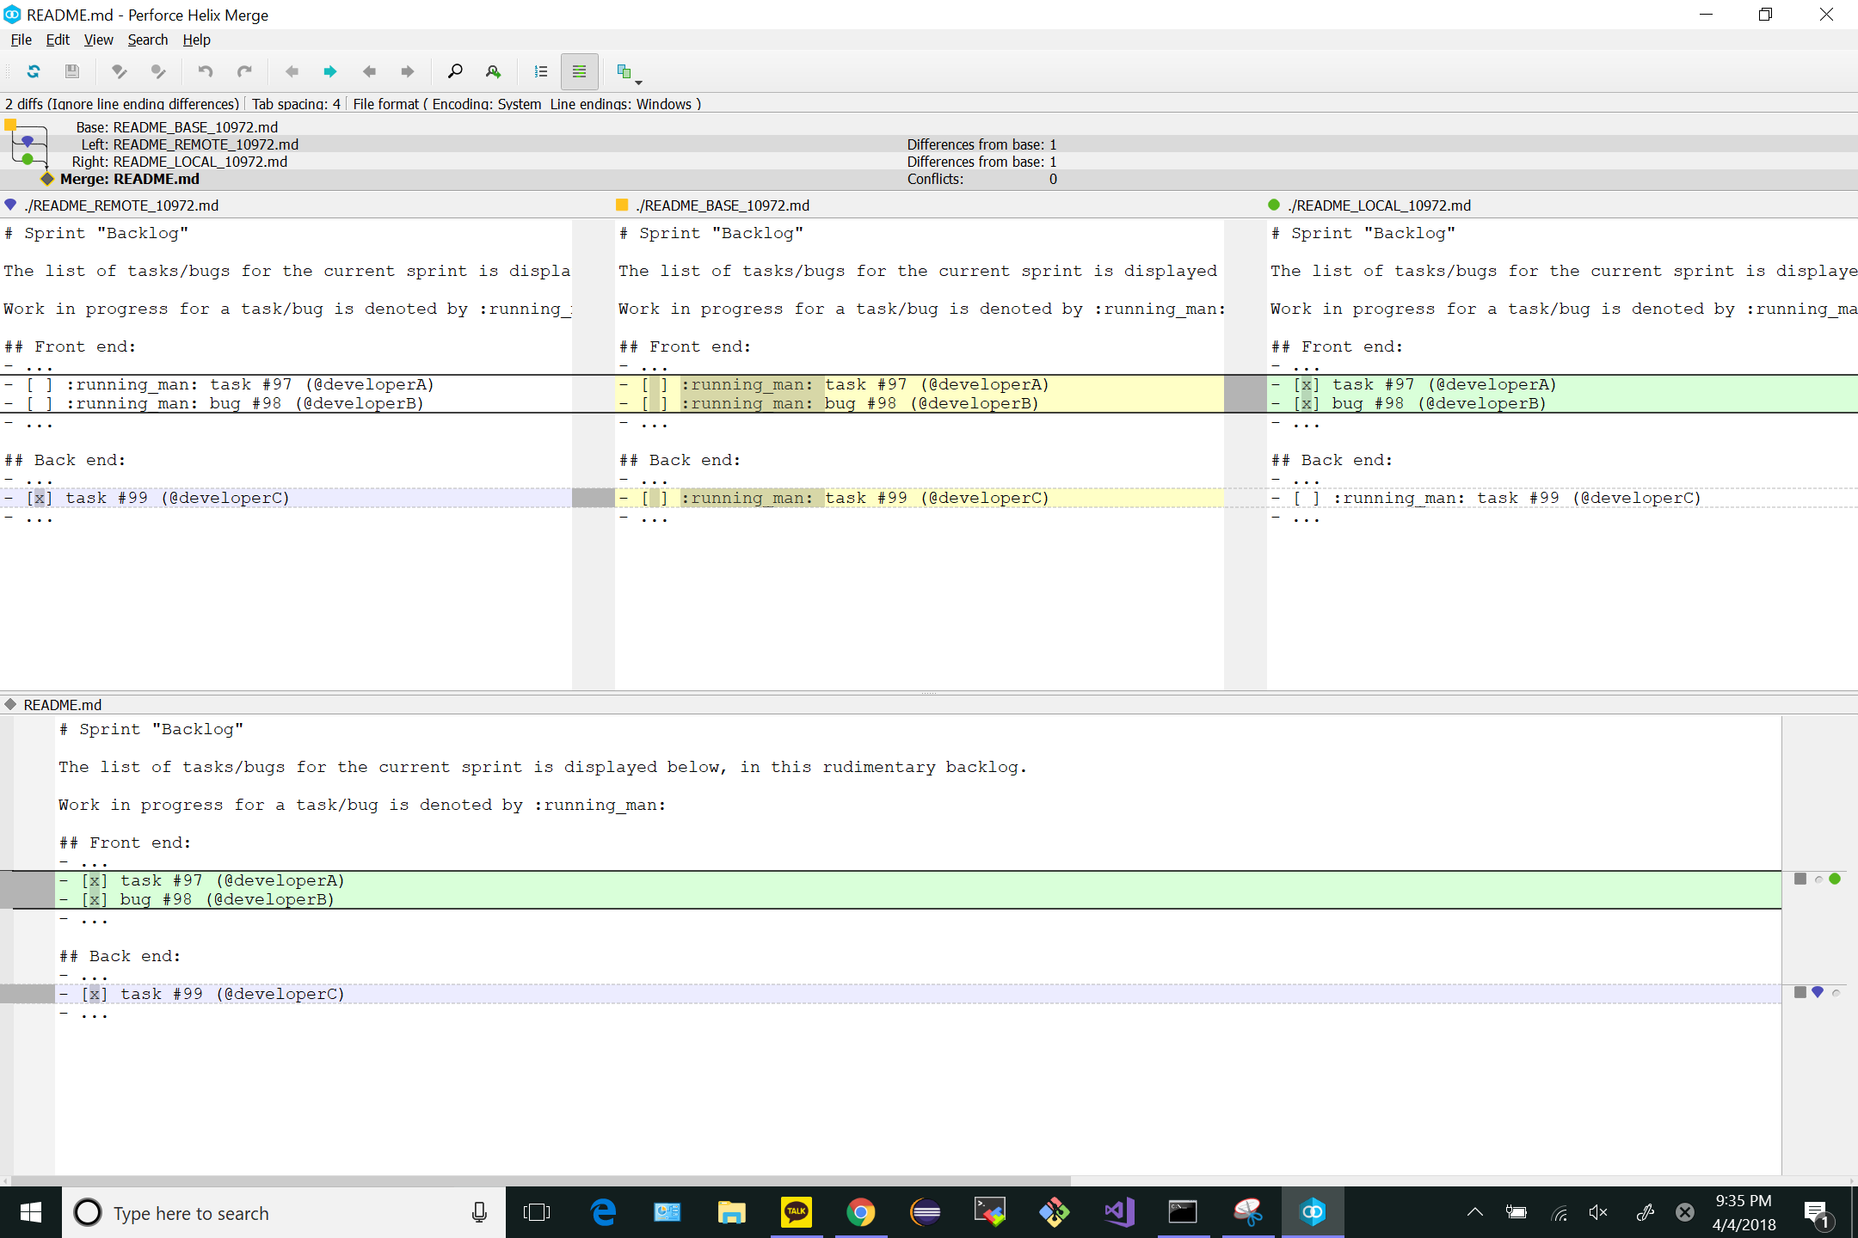

# GIT_VISUALIZATION_ALL_BRANCHES after completing Step 8:

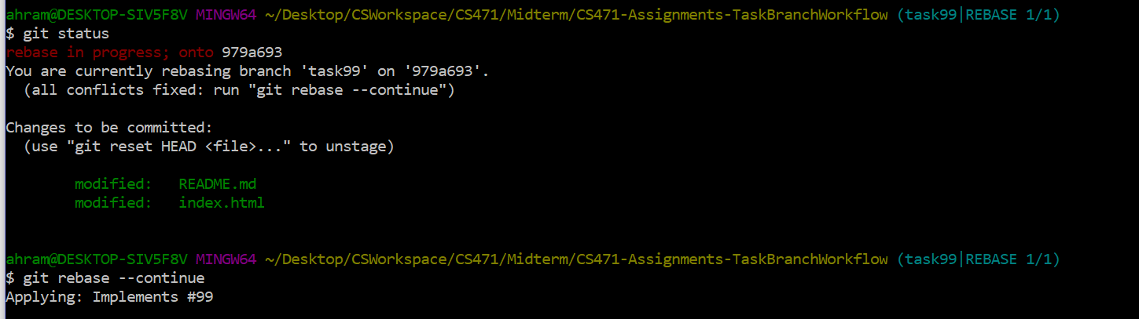

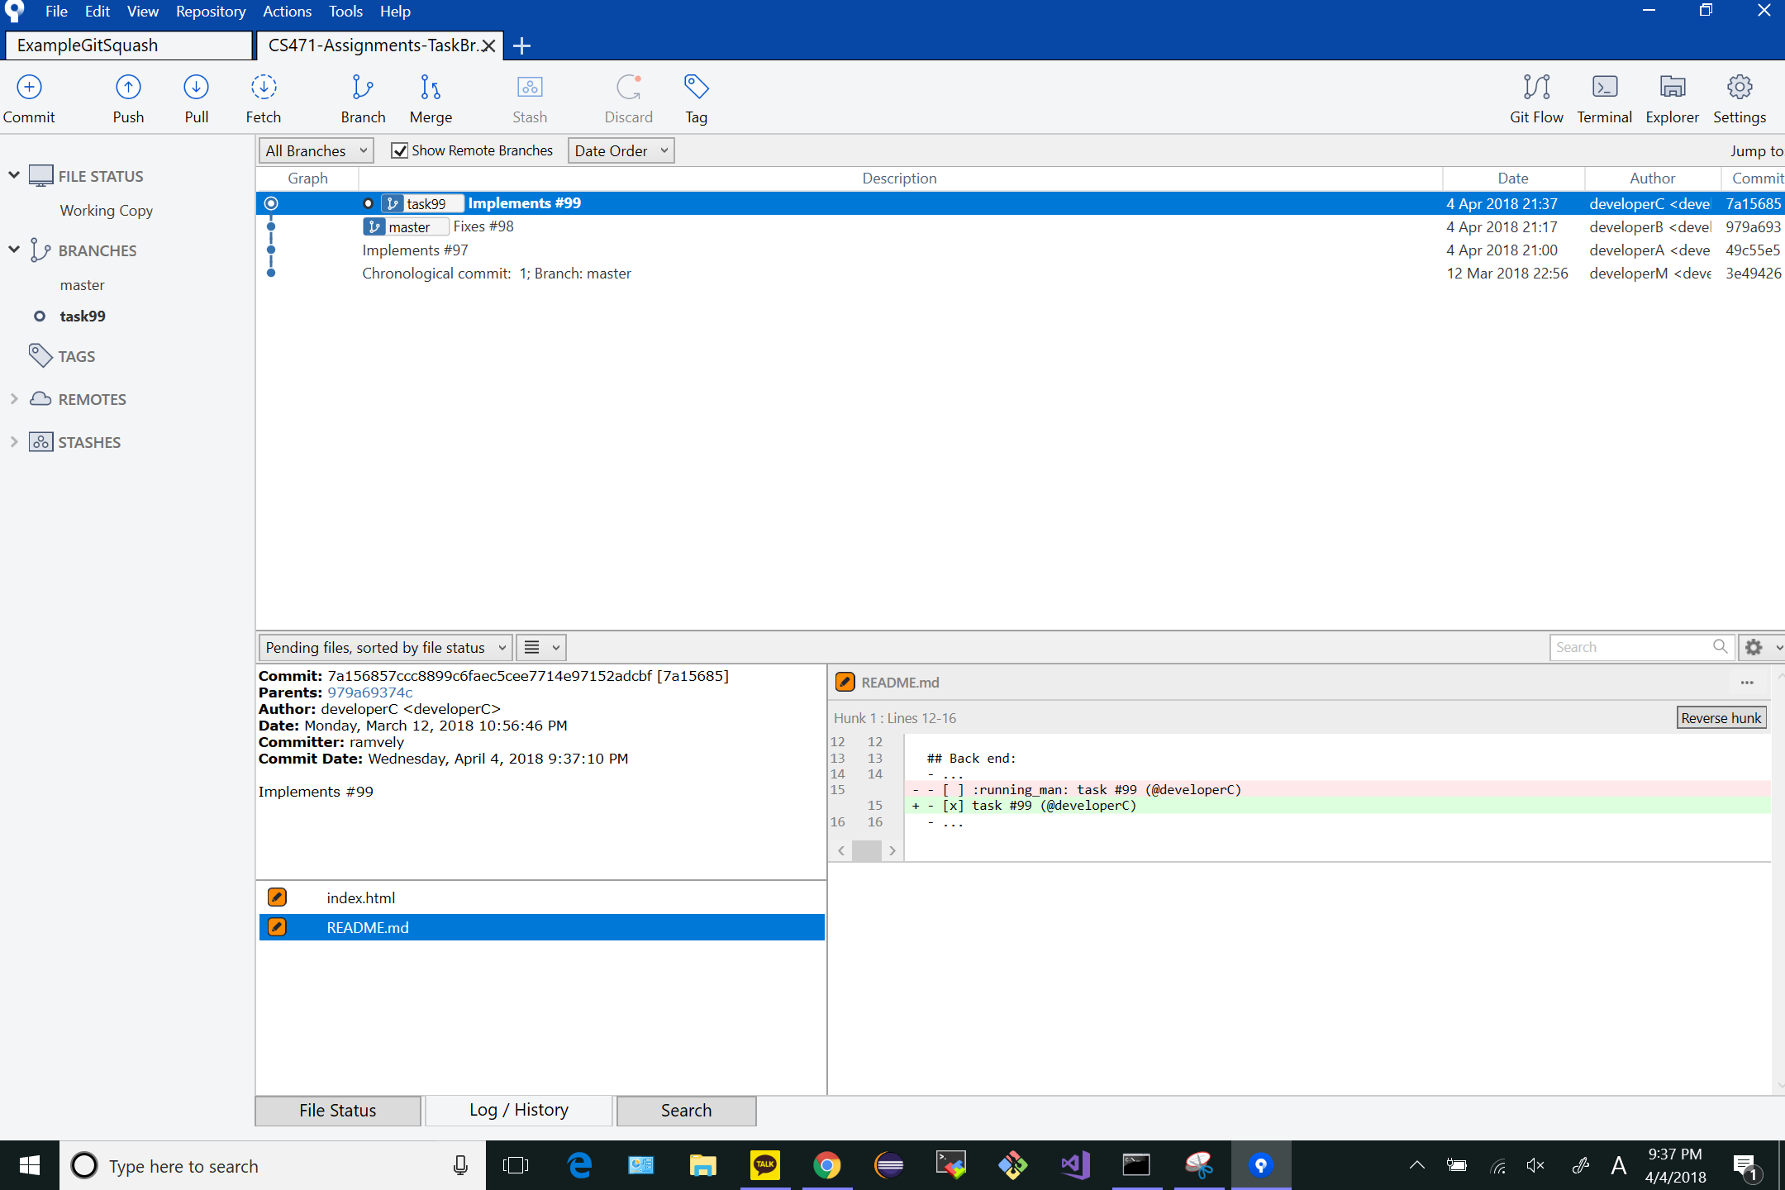

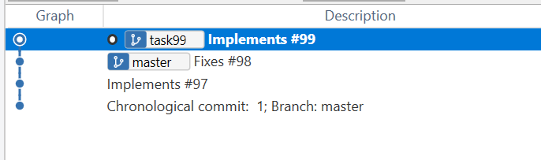

# GIT_VISUALIZATION_ALL_BRANCHES after completing Step 9:

